**Quality of Life and**

**Sense of Coherence**

**Michael J. Mahometa**

**April 28, 2016**

**SDS358**



**Introduction**

**Objectives:** Investigate the possible moderation of Practice Type (Medical, Nursing, or Surgical) on the effect of Sense of Coherence on Quality of Life among single nursing school students. Age was also included as a covariate in the model.

**Hypotheses:** There will be a significant overall interaction among the practice groups and the variable of interest.

**Methods**

**Sample:** Subjects were 101 single nursing school students were questioned about Coherence (quantitative) and Quality of Life (quantitative). Demographics such as student Age (quantitative) and Practice Type (categorical) were also collected. Initial investigations showed 6 participants with high Cook’s Distance scores. These subjects were subsequently removed.

**Analysis Method:** Regression with quantitative by categorical interaction.

**Descriptives**

**Response Variable:**

|  |  |  |
| --- | --- | --- |
|  | **Mean** | **SD** |
| **Quality of Life Mean** | 5.209 | 0.568 |

**Explanatory Variables:**

|  |  |  |
| --- | --- | --- |
|  | **Mean** | **SD** |
| **Coherence Mean** | 4.663 | 0.815 |
| **Age** | 26.914 | 6.061 |

|  |  |  |
| --- | --- | --- |
| **Medical Ward** | **Nursing** | **Surgical Ward** |
| 22 | 46 | 27 |

**Results**

**Overall Categorical Interaction:**

|  |  |  |  |  |
| --- | --- | --- | --- | --- |
| **Model** | **RSS** | **Df** | **F-value Statistic\*** | **P-value** |
| **No Interaction** | 20.182 |  |  |  |
| **With Interaction** | 17.852 | 2 | 5.6128 | 0.005 |

**Regression table:**

|  |  |  |  |  |
| --- | --- | --- | --- | --- |
| **Coefficient** | **Estimate** | **SE** | **t-value Statistic\*** | **P-value** |
| **Age** | 4.118 | 0.488381 | 8.432 | < 0.001 |
| **Medical** | 0.018 | 0.008148 | 2.176 | 0.032 |
| **Surgical** | -1.297 | 0.736351 | -1.762 | 0.081 |
| **Coherence** | -1.344 | 0.625714 | -2.148 | 0.035 |
| **Med*Coh** | 0.080 | 0.084795 | 0.954 | 0.343 |
| **Surg*Coh** | 0.387 | 0.153069 | 2.531 | 0.013 |

Overall Model Fit: F(6,86) = 9.958, p < 0.05; R2 = 0.4099

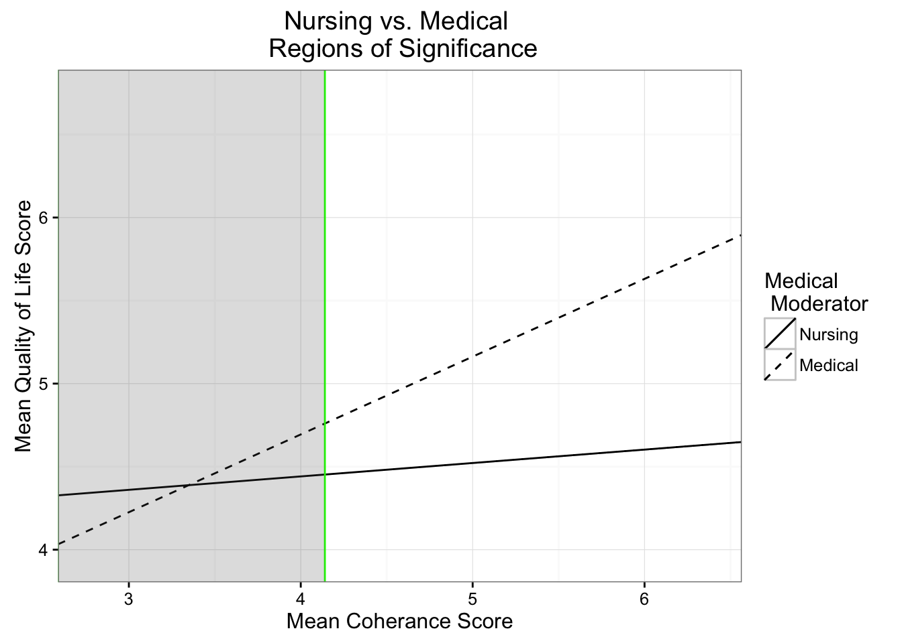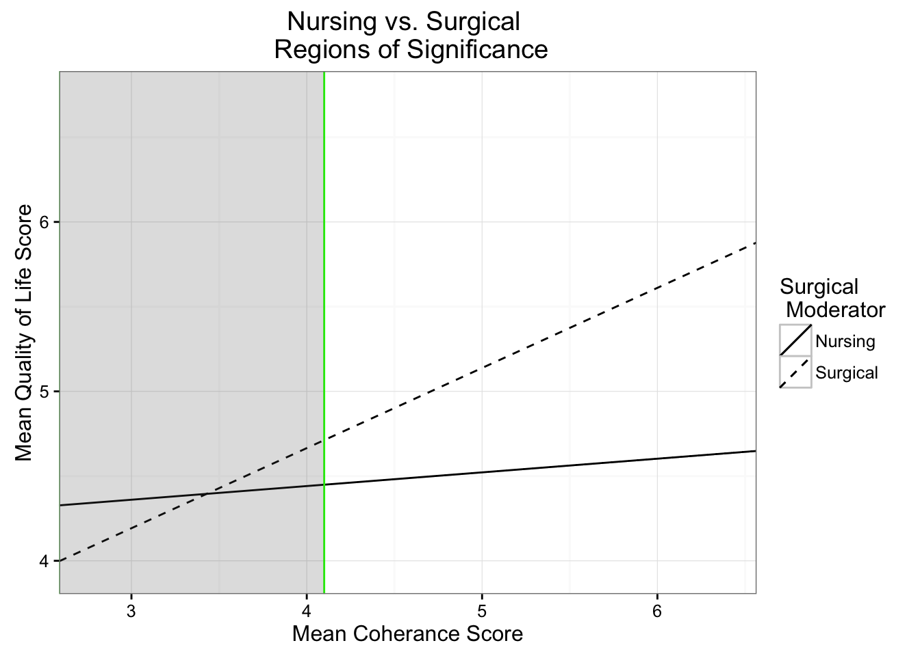

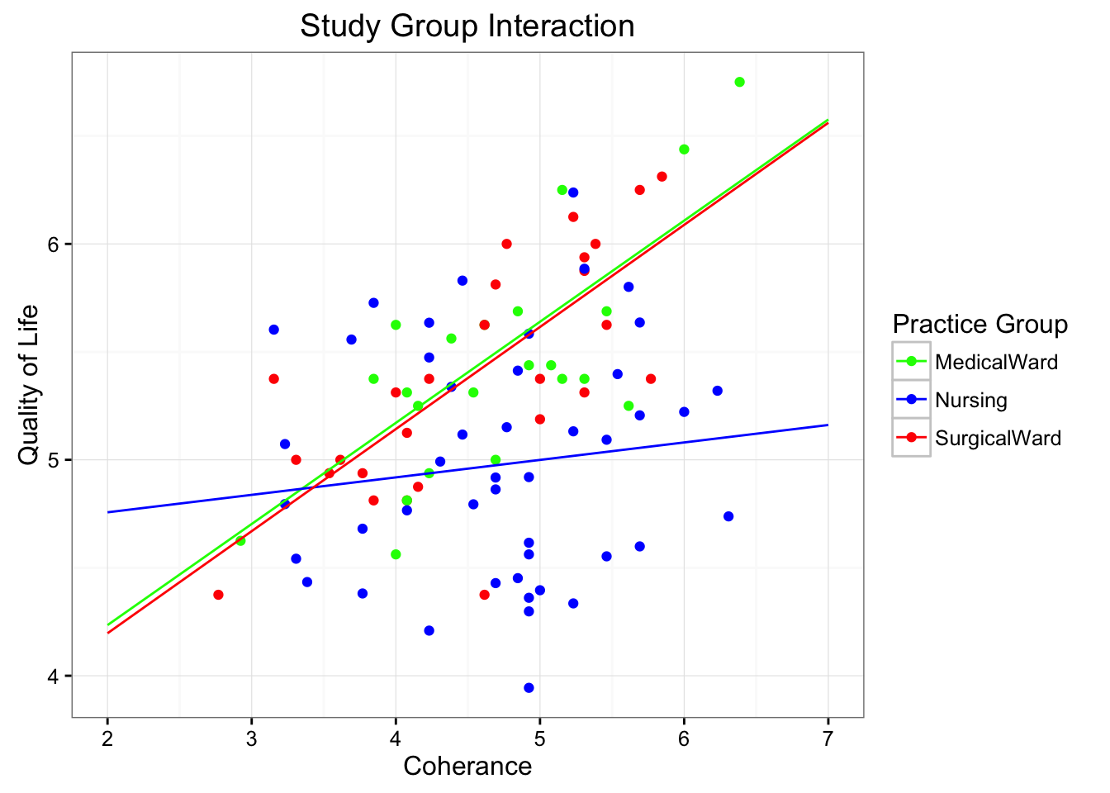

**Assumptions**

**Assumptions:** Homoscedasticity was checked and confirmed by a Residual vs. Fitted plot. Cook’s Distance was also examined for outlier removal.

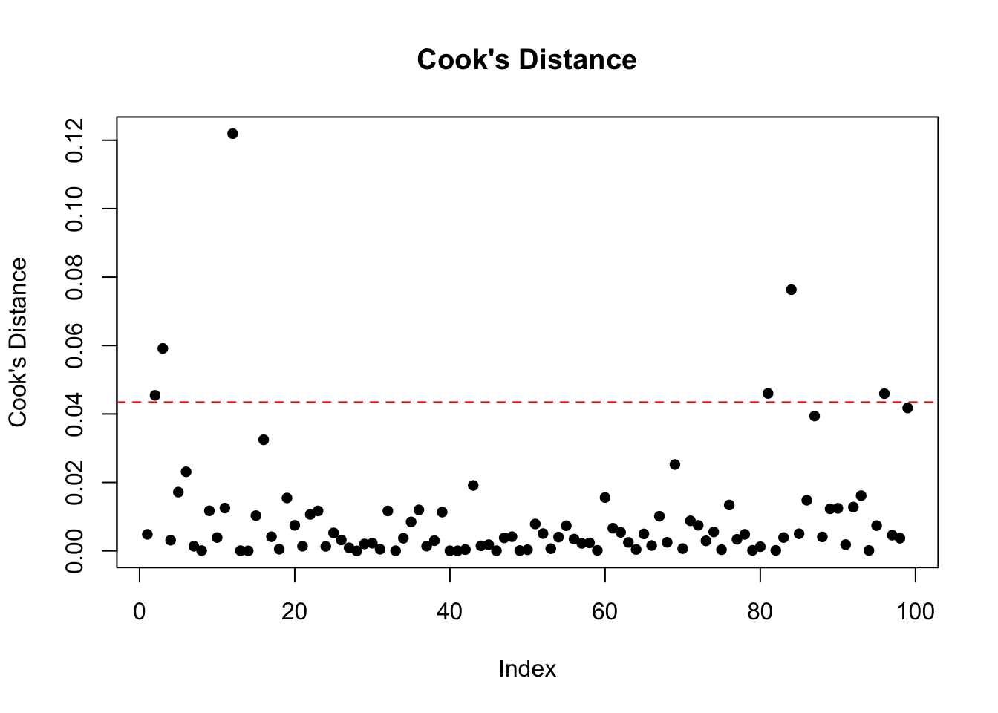

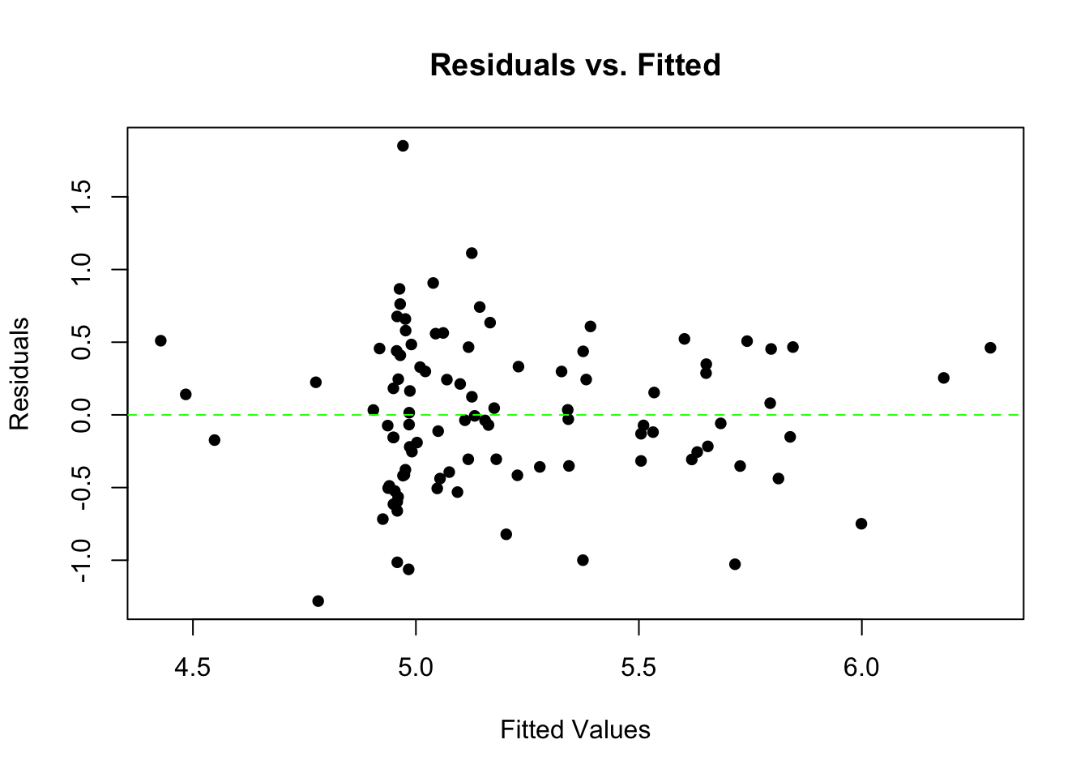

**Discussion**

**Interpretation:** The overall model was significant, F(6,86) = 9.958, p < 0.05, and there was a significant interaction between Practice Group and Sense of Coherence F(2, 86) = 5.613, p < 0.05. Evaluation of simple slopes showed a significant positive impact of Sense of Coherence on Quality of Life for the Medical group (beta = 0.468, t(89) = 3.696, p < 0.05) and the Surgical Group (beta = 0.473, t(89) = 4.540, p < 0.05) ,but not the Nursing Group (beta = 0.081, t(89) = 0.954, p = 0.343).

**Limitations:** The model does not take into account other factors that may be impacting quality of life, such as SES, Ethnicity, or time within the program.

**Implications:** Data was Norwegian nursing students, which has lead to a possible cultural confound. In order to generalize results, additional research is needed in other countries with other psychological pressures. As a results, the outcome of the current study may change, depending upon the cultural influence of the participants.

**References**: Original unaltered data file and publication:  
Kleiveland et al. (2015), Stress, sense of coherence and quality of life among Norwegian nurse students after a period of clinical practice. PeerJ 3:e1286; DOI 10.7717/peerj.1286